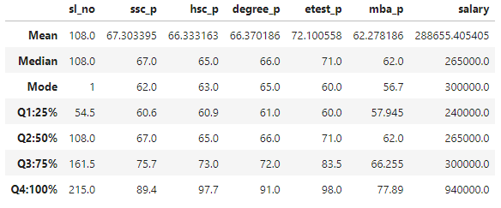

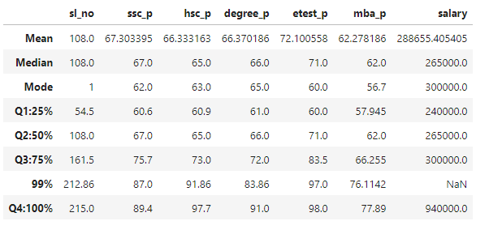

This is placement data. The expectation is to feed this data into ML model to check what salary can be expected in the future. Before ML, we are analyzing the data to find patterns.

**1. SSC (Secondary School Certificate Percentage - 10th Grade)**

* **Q1 (25th Percentile):** 60.6%
* **Q2 (Median, 50th Percentile):** 67%
* **Q3 (75th Percentile):** 75.7%
* **99th Percentile:** 87%

**Inference:**

* 50% of students have SSC percentages between 60.6% and 75.7%.
* The top 1% of students have an SSC percentage of 87% or higher, indicating a high level of performance among the top students.

**2. HSC (Higher Secondary Certificate Percentage - 12th Grade)**

* **Q1 (25th Percentile):** 60.9%
* **Q2 (Median, 50th Percentile):** 65%
* **Q3 (75th Percentile):** 73%
* **99th Percentile:** 91.12%

**Inference:**

* 50% of students have HSC percentages between 60.9% and 73%.
* The 99th percentile is significantly higher at 91.12%, showing a considerable leap in performance at the top end.

**3. Degree (Undergraduate Degree Percentage)**

* **Q1 (25th Percentile):** 61%
* **Q2 (Median, 50th Percentile):** 66%
* **Q3 (75th Percentile):** 73%
* **99th Percentile:** 83.86%

**Inference:**

* 50% of students have undergraduate degree percentages between 61% and 73%.
* The 99th percentile is at 83.86%, indicating that a small portion of students achieve significantly higher percentages.

**4. Etest_p (College Entrance Exam Percentile)**

* **Q1 (25th Percentile):** 57.945%
* **Q2 (Median, 50th Percentile):** 71%
* **Q3 (75th Percentile):** 83.5%
* **99th Percentile:** 97%

**Inference:**

* 50% of students scored between 57.945% and 83.5% on their college entrance exams.
* The 99th percentile score is very high at 97%, suggesting that the top performers excelled in the entrance exams compared to others.

**5. MBA (MBA Percentage)**

* **Q1 (25th Percentile):** 56.4%
* **Q2 (Median, 50th Percentile):** 66.255%
* **Q3 (75th Percentile):** 71%
* **99th Percentile:** 76.1142%

**Inference:**

* 50% of students have MBA percentages between 56.4% and 71%.
* The 99th percentile is at 76.1142%, showing a relatively moderate increase in performance among the top MBA students.

**6. Salary**

* **Q1 (25th Percentile):** 240,000 INR
* **Q2 (Median, 50th Percentile):** 265,000 INR
* **Q3 (75th Percentile):** 300,000 INR
* **100th Percentile (Max): 390,000 INR**

**Inference:**

* 50% of the students have salaries between 240,000 INR and 300,000 INR.
* **Range from Q3 to Max:** The salary increases from 300,000 INR at the 75th percentile to 390,000 INR at the 100th percentile. This represents a significant increase of 90,000 INR (approximately 30%) from the upper quartile to the maximum salary.

**Overall Inferences:**

* **SSC, HSC, and Degree Percentages**: These metrics have relatively consistent percentile increases, reflecting a steady distribution of student performance.
* **Etest_p (Entrance Exam Performance):** This metric shows the greatest variance in percentiles, indicating that students' performance on entrance exams varies widely.
  + **Q1 to Q3 Increase:** From 57.945% to 83.5% — an increase of 25.555%.
  + This significant jump suggests that there is a wide range of performance levels on the entrance exam, with the top 25% scoring substantially higher than the lower 25%.
* **MBA Scores:** The variance is less pronounced, indicating that MBA scores are more closely clustered.
* **Salaries:** The range from Q1 to Q3 suggests that salary distribution is less skewed. The salary increases from 300,000 INR at the 75th percentile to 390,000 INR at the 100th percentile. This represents a significant increase of 90,000 INR (approximately 30%) from the upper quartile to the maximum salary